Code Example 1: Penalty Method
Code: week_7_example_1.py
Code description:
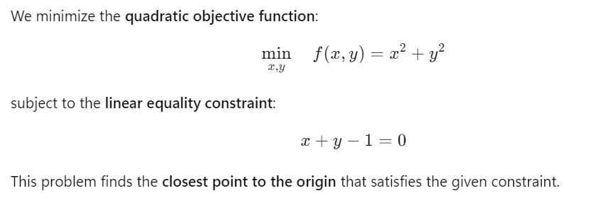
Code Example 2: Method of Lagrange Multipliers
Code: week_7_example_2.py
Code description:
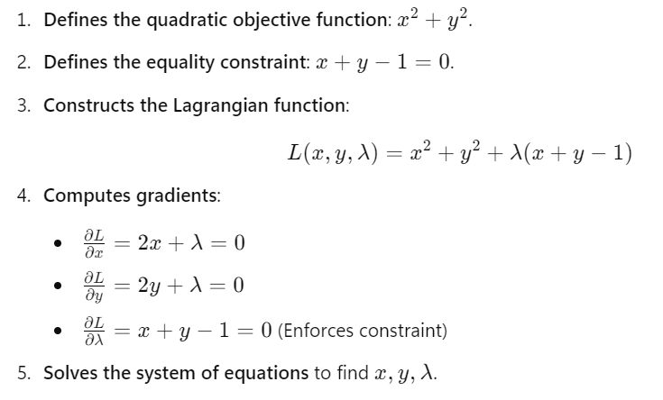
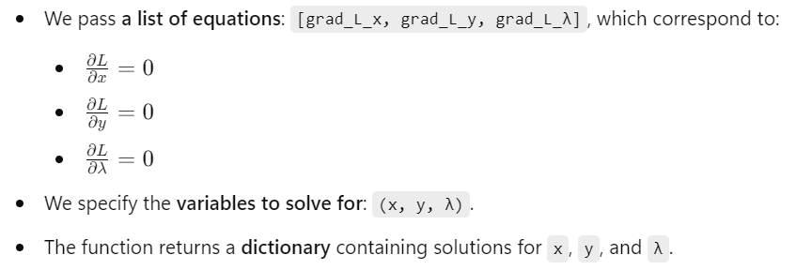
Code Example 3: Augmented Lagrangian Method
Code: week_7_example_3.py
Code description:

TODO finish

Code Example 4:
Code: week_7_example_4.py
Code description:

